User case diagrams: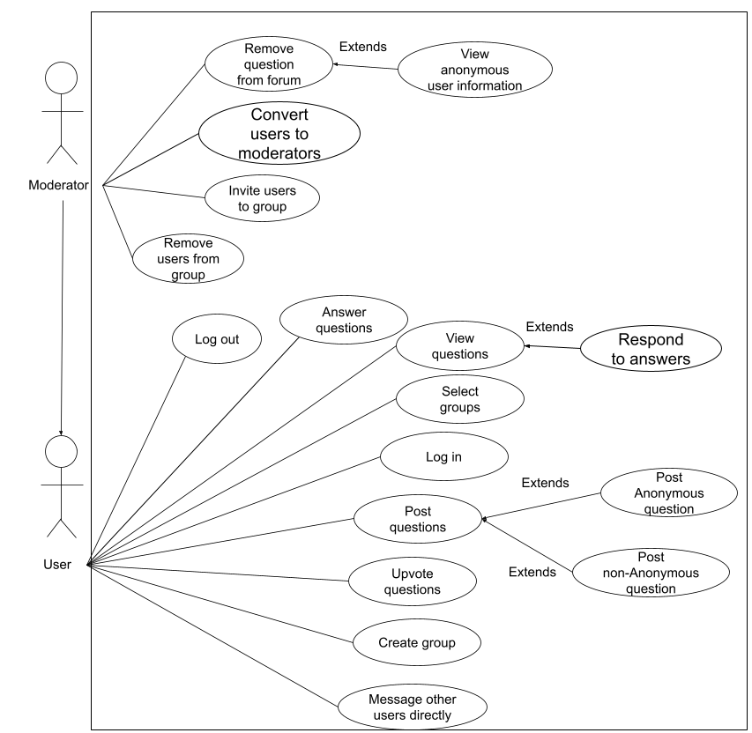
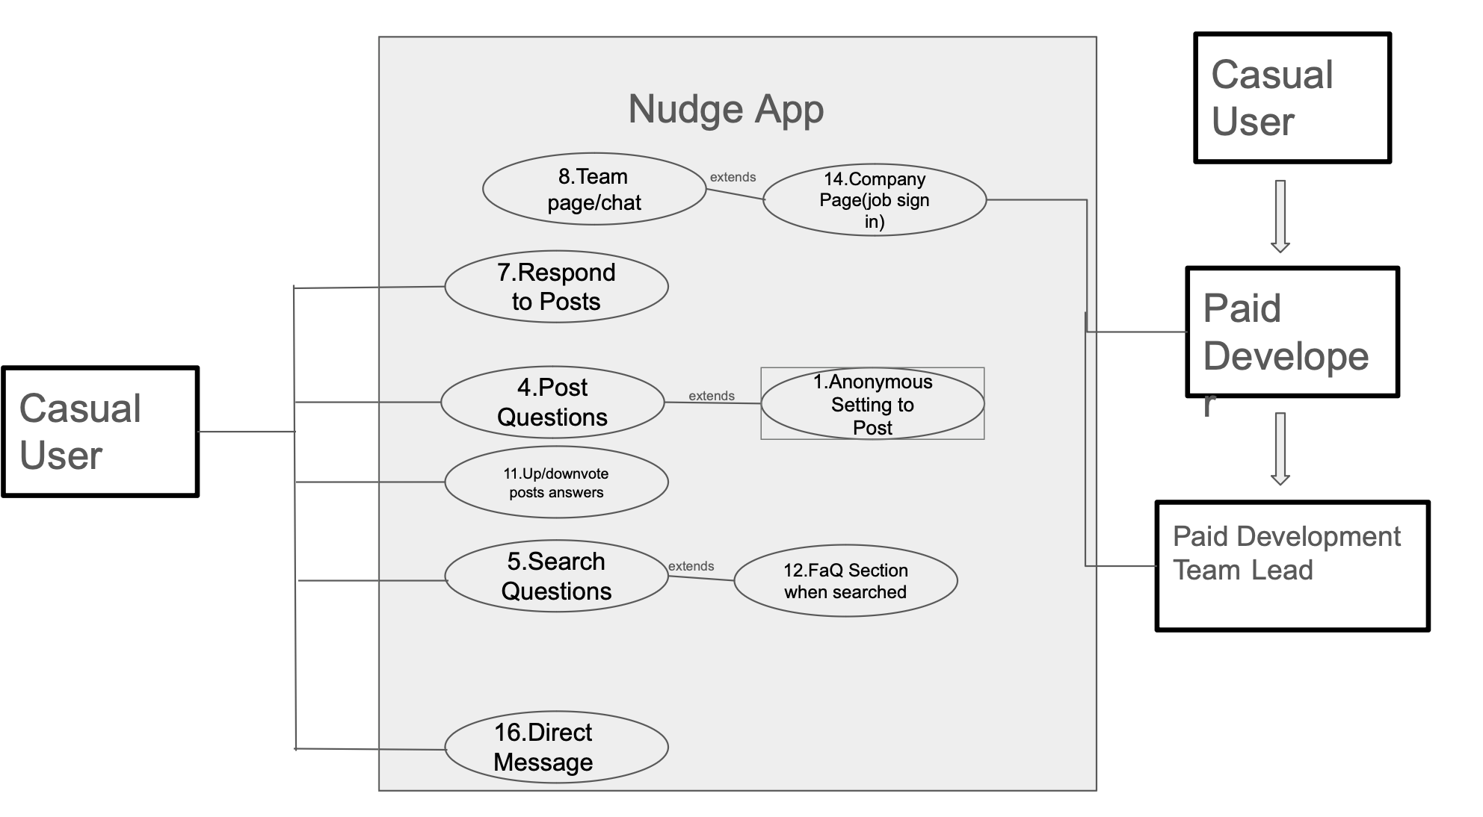

Use case: Answer Questions
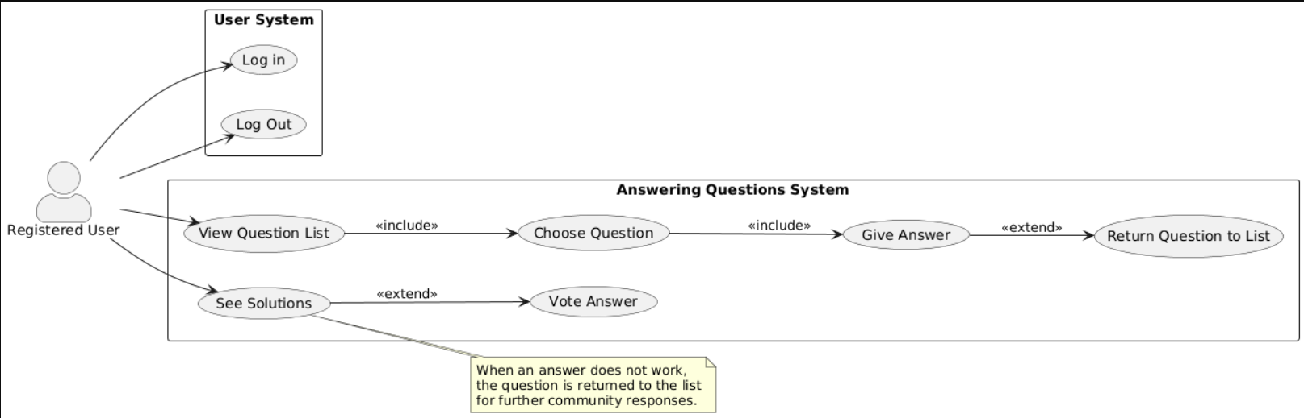

Name: | Answering User Questions
Actors: | Registered user, system
Goals: | Answer a question asked by another Registered User.
Preconditions: | SUS has two or more registered users  One of the users has posted a question.  The question is not part of the FAQ system.
Summary: | The Registered user chooses to answer a question on the list, after they choose their question and submit their answer, the user that asked the question gets notified.
Related Use Cases: | Related cases are Ask question, and Give feedback
Post Conditions: | The question has been removed from the list of questions, and the asking User can vote whether or not the Answer was successful.

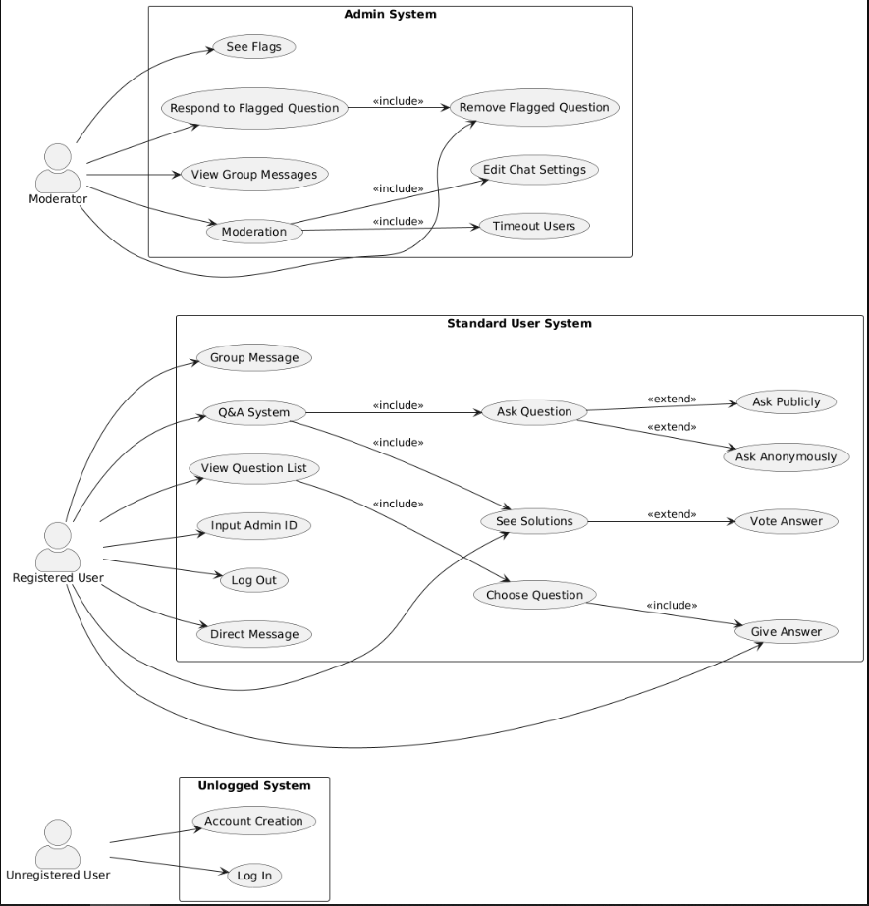

Revised:
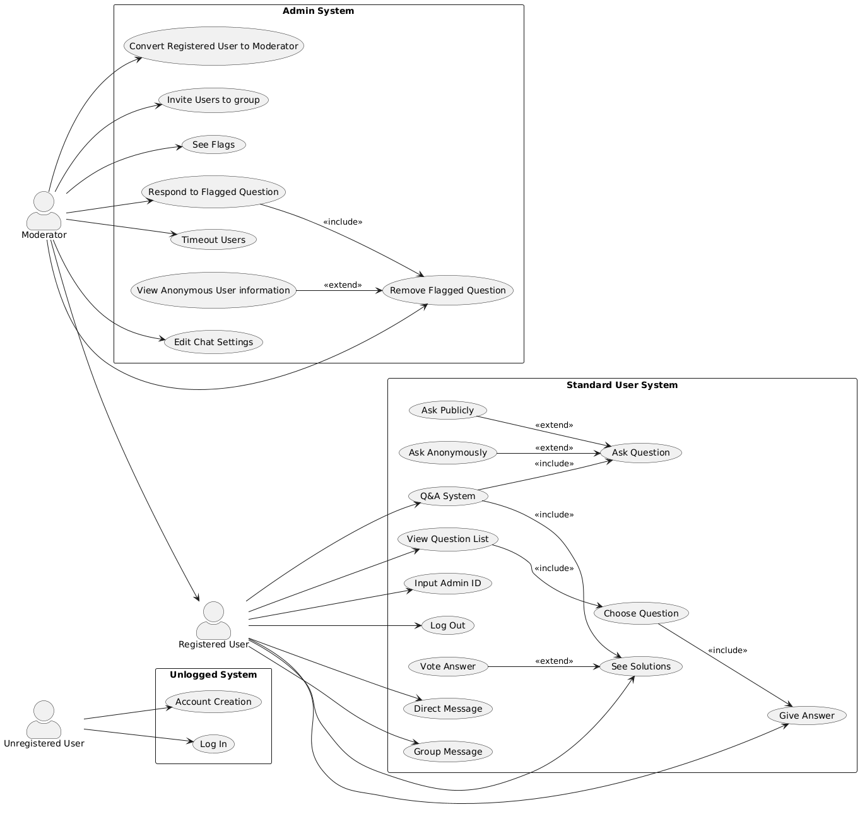

User Descriptions:

Name: | Respond to an answer on an user asked question
ID: | 58
Description: | As a junior developer, I would like to be able to respond to feedback I receive so that I may acknowledge if it has solved the problem.
Success Postcondition: | Another user can see either a response or an upvote from the user whose question they answered.
Precondition | The user is signed in and on a forum, viewing a question they asked with an answer from another user.

USER STEPS:  1. The user opens their question.  3. The user will select the response to expand it.  5. The user will give feedback.  5a. User will type into text box  5b. User will press button  7a.User will send the message. | SYSTEM RESPONSE:  2.System shows a detailed question screen containing responses from other users if any exist.  4.1.System expands the response showing full response  4.2. System offer prompt for user to type in  4.3.System will display a button for the user to give feedback  6a.System prompt reflects text written in text box  6b.User will see button change, other user will have their score increment by one  8a.System displays text under full response to the question.

Use Case Descriptions:
Name/Title: | 1.Anonymous Setting to Post questions
ID: | 1
Description: | This feature should allow users that want to share anything have the option to toggle an anonymous feature. By having changing temp ids take the place of users we can boost confidence and interaction.
Related Use cases: | Respond to Posts  Create Posts
Precondition: | The user has the app open and has been prompted to create a post or response.
Success Postcondition: | When a post is created, the user's account is successfully hidden.

USER STEPS:  1. Clicks create post  3. Click anonymous toggle within post ui  5. Create post and share | SYSTEM RESPONSE:  2. Opens post creation interface  4. Change toggle ui to on and place temp filler id over the users account  6. Share what user posted with anonymous identity

Name/Title: | 7.Respond to Posts
ID: | 7
Description: | This should be a core interaction function where people can leave comments under posts or questions. This will allow people to share answers or feelings which is just as a needed function for our app.
Related Use Cases: | Anonymous Function  Post Questions
Precondition: | The user has the app open, and is looking at posts.
Success Postcondition: | Users can type in the comment box below posts, and share.

USER STEPS:  1. See post, click to open.  3.Click on the text box and type a response.  5. Share comment/response. | SYSTEM RESPONSE:  2. Open question interface with a text box on bottom.  4. Open the comment box then write the text.  6. Shows response under said post.

Name/Title: | 11.Up/downvote posts answers
ID: | 11
Description: | This feature will allow users to click a good and bad reactionary button thats on each post or comment. This will allow people to express themselves, organize correct or incorrect answers and do the same for good information or bad information.
Related Use Cases:
Precondition: | The user has the app open, and is scrolling posts from a search or a board.
Success Postcondition: | Users can click an upvote or downvote button on any post or response.

USER STEPS:  1.User searches for a question.  3. The user is looking at posts and clicks on given upvote downvote buttons attached to all posts and comments. | SYSTEM RESPONSE:  2.App shows responses.  4. Reacts by adjusting ui to show reaction, and updates count of reactions and refilters comments on reaction count.

List of Use Case names:

- Create Question
- Respond to Question
- Organize questions within specific board
- View posted questions
- Enable anonymity
- Evaluate usability
- view FAQ page
- message other users
- message groups
- report questions or responses
- remove questions or responses
- Join company

GPT Inspiration 2.0:
Post Questions Privately
Ask Questions Anonymously
Acknowledge Feedback Received
Join Public Forum
Start Private Chat
View Past Discussions
Answer Developer Questions
Find Known Solutions
Access Team FAQs
Receive Question Notifications
Request Work Feedback
Discuss Submitted Work
Report Improper Questions
Remove Reported Content
Organize Help Requests
Reward Helpful Answers

Aidans UCD:

Name/Title: | 1.Anonymous Setting to Post
ID: | 1
Description: | This feature should allow users that want to share anything have the option to toggle an anonymous feature. By having changing temp ids take the place of users we can boost confidence and interaction.
Related Use cases: | Respond to Posts  Create Posts
Precondition: | The user has the app open and has been prompted to create a post or response.
Success Postcondition: | When a post is created, the user's account is successfully hidden.

USER STEPS:  1. Clicks create post  3. Click anonymous toggle within post ui  5. Create post and share | SYSTEM RESPONSE:  2. Opens post creation interface  4. Change toggle ui to on and place temp filler id over the users account  6. Share what user posted with anonymous identity

Name/Title: | Give Answers(.Respond to Posts)
ID:
Description: | This should be a core interaction function where people can leave comments under posts or questions. This will allow people to share answers or feelings which is just as a needed function for our app.
Related Use Cases:
Precondition: | The user has the app open, and is looking at posts.
Success Postcondition: | Users can type in the comment box below posts, and share.

USER STEPS:  1. See post, click to open.  3.Click on the text box and type a response.  5. Share comment/response. | SYSTEM RESPONSE:  2. Open question interface with a text box on bottom.  4. Open the comment box then write the text.  6. Shows response under said post.

Name/Title: | 11.Up/downvote posts answers
ID: | 11
Description: | This feature will allow users to click a good and bad reactionary button thats on each post or comment. This will allow people to express themselves, organize correct or incorrect answers and do the same for good information or bad information.
Related Use Cases:
Precondition: | The user has the app open, and is scrolling posts from a search or a board.
Success Postcondition: | Users can click an upvote or downvote button on any post or response.

USER STEPS:  1.User searches for a question.  3. The user is looking at posts and clicks on given upvote downvote buttons attached to all posts and comments. | SYSTEM RESPONSE:  2.App shows responses.  4. Reacts by adjusting ui to show reaction, and updates count of reactions and refilters comments on reaction count.

Name/Title: | 14.Company Page(job sign in)
ID: | 14
Description: | This will be a major tab on our man page where when you open it you are greeted with a sign in page. A company you work for may register with our app, and then you will find that company sign in, then you can interact with job specific pages within our app. This helps you find questions relevant to other new hires in your position which can help build confidence in users.
Related Use cases: | Team Chat  Post Question
Precondition: | The user has the app open.
Success Postcondition: | Users can sign in separately with the company.

USER STEPS:  1. On the main page the user clicks the 'Jobsite’ page.  3. The user searches and finds/selects the company.  5. User signs on. | SYSTEM RESPONSE:  2. Open sign in page where user searches through companies registered to our page, and then sign in through that company.  4. Open company sign on page.  6. Allows access to the same functions of the main software but strictly relevant to job specific questions, and one further at a specific location.

Name/Title: | 5.Search Questions
ID: | 5
Description: | This is where if anyone has a question related to comp sci or programming that may be common, you can search and find it. If you want a specific language or problem that can be filtered for.
Related Use cases: | Respond to Posts  Create Posts
Precondition: | The user has the app open, and has opened the questions tab.
Success Postcondition: | Users can see results similar to question search.

USER STEPS:  1. The user opens the questions tab from the main page.  3. Navigates to the search and filter section and searches for specific problems. | SYSTEM RESPONSE:  2. Open questions page where people post and respond to questions.  4. Opens search bar, receives text and filters, and then finds relevant posts and lists to users.

Name/Title: | Direct Message
ID: | 16
Description: | This is a private communication feature where from someone's profile directly, or from the messages tab, you can send messages. This is useful for users who prefer private communication and maybe to help specify certain issues more clearly.
Related Use cases: | ID:5 Search Posts  ID:7Respond to Posts
Precondition: | The user has the app open and is signed in
Success Postcondition: | Users can privately message other users.

USER STEPS:  1. The user clicks on the messages button/tab associated with another user.  5. Type in the text box whatever message and hit enter, or share button. | SYSTEM RESPONSE:  2. This should then open the messages page showing the current chat history with the other user. As wel as a text input box  4. Show previous messages, and a text box.  6. The message box will receive the text, then share the message with other user. Sharing it in their messages tab.

Name/Title: | 8.Team page/chat
ID: | 8
Description: | Within your company location it is likely desired that you could chat with your team, so separate from private messages and Q & A posts, within your job page there are separate team chats handled by a team lead likely.
Related Use cases: | Company Page
Precondition: | The user has the app open, and has signed in with a company, and has been set to teams by a team lead.
Success Postcondition: | Users can share messages with multiple company members at the same time.

USER STEPS:  1. The user clicks the company page tab from the app's main page.  3. In the company page the user finds the team tab which the user clicks.  5. The user locates a chat service for their group, opens messages.  7. The user types and shares messages. | SYSTEM RESPONSE:  2. Opens personal company page.  4. The app opens the team tab which allows the same functions, of an QnA tab, previous pinned posts, but now with group team chat.  6. Shows previous messages, with names above them, allowing chat messages  8. Share the message with all members of team chat.

Name/Title: | 4.Post Questions
ID: | 4
Description: | Major function for users to post specific questions when they can't find relevant answers. Maybe the user needs personally specific advice to solve a problem,
Related Use cases:
Precondition: | The user has the app open.
Success Postcondition: | The user can post a public question that people can find and answer.

USER STEPS:  1. The user is on the main page and clicks the questions tab.  3. The user clicks the create post button.  5. User types question out, and adds a tag for the python language.  7. The user shares their question publicly. | SYSTEM RESPONSE:  2. Opens questions tab, showing major popular questions, or recent searches.  4. This opens the interface to post a public question, with a text box for a title and body.  6. Receives text, and filtered posts with those with similar tags.  8.Shares the question publicly and it can be found and responded to by other users via search.

Name/Title: | 12.FaQ Section when searched
ID: | 12
Description: | When looking for information, if you don't want to wait for personal responses, there might be easy answers to very common questions. In the questions page when you search, there will be a toggle to show the most frequently asked questions solved, relevant to your question.
Related Use cases: | Respond to Posts  Anonymous function
Precondition: | The user is in the app and, has an account, and knows how to search,
Success Postcondition: | You can find commonly asked questions when you search for solutions.

USER STEPS:  1. The user opens the questions tab from the main page.  3. The user searches for a specific question.  5. The user swaps the page to see the commonly sked questions with answers. | SYSTEM RESPONSE:  2.The app opens the questions tab where you can search.  4. The app shows relevant answers and loads FaQ regarding the searched keywords on a separate tab.  6. The page shows the most common asked questions regarding the searched subject.

Name/Title: | respond to comments on post
ID: | #
Description: | As a junior developer, I would like to be able to respond to feedback I receive with comments so that I may acknowledge if it has solved the problem.
Related Use Cases: | respond to answers
Precondition: | logged in and viewing a post with answers
Success Postcondition: | The user’s comment is posted below the answer given to the original question.

USER STEPS:  1. User clicks the ‘comment’ button below an answer or comment  3. User types out their comment within the text box  4. User clicks the ‘comment’ button below textbox | SYSTEM RESPONSE:  2. textbox appears below selected answer or comment  4. Checks comment for any prohibited words  4.1. If any prohibited words are found, prompt the user to change their comment and don’t continue  5. Posts question below the chosen answer or comment with a slight indent.

Name/Title: | upload code in posts
ID: | #
Description: | As a developer, I would like to be able to ask for feedback from other developers about my work, so that I know what tips people could give me to improve.
Related Use Cases: | Ask question
Precondition: | User is logged in and has their program downloaded
Success Postcondition: | User is able to post a question containing code

USER STEPS:  1. User clicks on the ‘post question’ button  3. User clicks the ‘attach file’ button  5. User selects the program file  5.1. User clicks on the desired program file  5.2. User types file name in answer textbox  6. click ‘select file’ button  9. click the ‘post’ button | SYSTEM RESPONSE:  2. Textbox appears and prompts user to type question  4. Open the user’s file explorer and prompt user to select file  7. scan chosen file to ensure it is safe  7.1. If it is found to be unsafe, prompt the user and do not attach the file  8. Attach chosen file to post so others can download it  10. post the question with with chosen attachments

Name/Title: | Organize questions within a board
ID: | #
Description: | As a team lead, I would like to be able to have access to a screen where I can organize all questions asked in a given help board, so that I can identify where they need more training.
Related Use Cases:
Precondition: | User is logged in, a team lead, and is viewing a question board
Success Postcondition: | The question board organizes its questions in the way specified by the user.

USER STEPS:  1. User clicks the ‘sort’ button at the top of the board  3. User clicks on desired option | SYSTEM RESPONSE:  2. Provide a drop down menu with multiple options  4. shows a list containing all the questions organized in the way selected

Name/Title: | Usually in the form of <action> + <object>, aim for 3-7 words
ID: | A numeric identifier
Description: | As a senior developer, I would like to be able to answer other developers' questions so that I can help them learn best practices at our company.
Related Use Cases: | Instance of: <Use case ID and short name>, <Use case ID and short name>, …  Included by: <Use case ID and short name>, <Use case ID and short name>, …  Inclusions:<Use case ID and short name>, <Use case ID and short name>, …  Extensions: <Use case ID and short name>, <Use case ID and short name>, …
Precondition: | Relevant/related state or conditions that must be met before the Use Case is started
Success Postcondition: | Relevant/related state or conditions will result if the use case is completed successfully. Some Exceptions may result in the failure to meet the Success Postcondition.

USER STEPS:  1.  3.  5.  … (add more steps if needed) | SYSTEM RESPONSE:  2.  4.  6.  … (add more steps if needed)

